**G H Raisoni College of Engineering & Management, Pune**

**(An Autonomous Institution Affiliated to Savitribai Phule Pune University, Pune)**

**New Gat No. 1200, Domkhel Road, Wagholi, Pune 412207, Maharashtra State, India**

**Email: ghrcem.pune@raisoni.net Web:-** [**https://ghrcem.raisoni.net/**](https://ghrcem.raisoni.net/)

**Department of Electronics & Telecommunication Engineering**

**A**

**Synopsis of Project**

**On**

**AI Driven Agribot**

**Submitted By**

1. **Vaibhav Nrupnarayan (Roll.no: 47)**
2. **Harish Bagul (Roll.no: 24)**
3. **Abhiman Bade (Roll.no: 3)**

**Under the Guidance**

**of**

**Dr. Kavita Joshi**

**In the partial fulfillment**

**of**

**Degree of Bachelor in Engineering**

**In**

**Electronics & Telecommunication Engineering**

**G H Raisoni College of Engineering & Management, Pune**

**AY 2024-25**

**Winter Term**



**Project Synopsis**

1. **Introduction:**

Agriculture plays a critical role in the economy, particularly in regions where rice is a staple crop. Traditional rice planting methods are labor-intensive and time-consuming, often leading to inefficiencies and increased costs. To address these challenges, the "Agricultural Rice Plantation Robot using AI & IoT" project aims to develop an innovative solution that automates the rice planting process.

This project leverages Artificial Intelligence (AI) and Internet of Things (IoT) technologies to create a smart, autonomous robotic system capable of performing precise and efficient rice planting. The robot is designed to navigate paddy fields, plant rice seedlings accurately, and monitor environmental conditions in real-time. By integrating AI, the robot can make intelligent decisions to optimize planting patterns and adapt to varying field conditions, ensuring uniform seed distribution, and improving crop yield. IoT sensors will provide continuous data on soil moisture, temperature, and other critical parameters, enabling farmers to make informed decisions about crop management.

The introduction of this robotic system aims to revolutionize rice farming by reducing dependency on manual labor, increasing planting accuracy, and enhancing overall productivity. This project represents a significant step towards modernizing agriculture and ensuring food security through technological innovation.

1. **Literature Survey:**

In the paper named Smart farming for improving agricultural management, Collection of the data and analysing it for the future procedure on the crops on the fields according to the quality of the plants.[1]

In this paper Application of AI techniques and robotics in agriculture, Detecting the objects in the fields using AI and deciding the objects.[2]

Here in Design and development of the agricultural robot for crop seeding, the seed of the plant can be sowed without the human requirements with this automated seed planter robot.[3]

Here in this Detection of unhealthy region of plant leaves using Image Processing and Genetic Algorithm,

An ANN based classifier classifies different plant diseases and uses the combination of textures, colour and features to recognize those diseases. It is used to remove that noise. The training samples can be increased and shape feature and color feature along with the optimal features can be given as input condition of disease identification.[4]

Here in paper named Effect for a Paddy Weeding Robot in Wet Rice Culture, the ground is uneven, and the rows of rice seedlings are not always straight, as is the case in terraced paddies. It is used to detect rice seedlings and measure the movement direction.[5]

Robotics and Automation in Agriculture: Present and Future Applications, this new technology is used for position and attitude sensor for navigation system. To monitor the seed falling trajectories which is attached at the pneumatic planter outlet. It is used in detecting peanut leaf spots.[6]

1. **Problem Statement:**

Rice planting is a labor-intensive and time-consuming process that requires significant manual effort, leading to increased costs and reduced efficiency in agricultural practices. Traditional methods often result in inconsistent planting, suboptimal crop yields, and an inability to promptly respond to changing environmental conditions.

To address these challenges, there is a need for an innovative solution that can automate the rice plantation process, ensuring precision, efficiency, and adaptability. The development of an Agricultural Rice Plantation Robot using AI and IoT aims to solve these issues by providing an autonomous system capable of performing precise rice planting, real-time monitoring of environmental conditions, and data-driven decision-making to optimize crop management. This solution seeks to enhance productivity, reduce labor dependency, and improve overall agricultural outcomes in rice farming.

1. **Objectives:**
2. Developing a mechanism capable of planting the rice plant.
3. Checking the quality of rice plant using Image Processing and Machine learning.
4. **Scope of the Project:**

The scope of this project can be defined from two perspectives:

Functionality:

* Planting: precisely planting rice plant at the desired depth and spacing.
* AI will be limited to planting-related decisions based on data acquisition:
  + Planting on the appropriate spacing.
* AI and Machine learning algorithms will be designed for:
  + Image recognition.
  + Decision-making on plant quality.
  + Disease detection.

Important Considerations:

* The initial scope might not be able to complete the tasks like weed control, fertilization, or harvesting due to their added complexity.
* The focus will be on developing a functional prototype demonstrating the core functionalities.
* Depending on resources and project goals, the scope can be expanded to include additional features or functionalities in the future.

1. **Block Diagram & Description:**

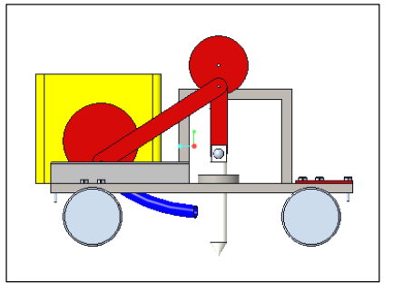

Fig.1 3D diagram of rice planter

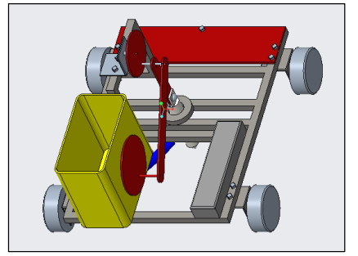

Fig.2 Side view diagram of rice planter

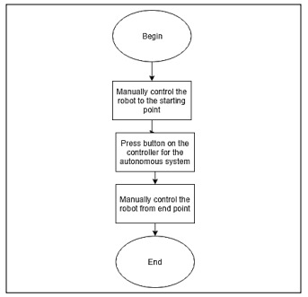

Fig.3 Block diagram of mechanism of rice planter Agribot

1. **Hardware & Software used:**

The agricultural robot prototype consists of four geared DC motors–each with a voltage and current rating of 5 V – 12 V and 2.4 A, respectively–driving each wheel to enable movement of the robot base. For this application, DC motors were selected due to their high torque characteristics, good reliability, and low maintenance requirements. The high torque and precise speed regulation offered by the DC motors ensure that the robot can overcome loose soil or muddy surfaces as well as rough terrains in the agriculture fields without issue.

The DC motors are driven by two low-cost L298N motor drivers. The motor drivers act as a current amplifier by receiving a low-current control signal from a microcontroller and converting it into a higher-current signal which can drive a motor. The L298N motor driver is powerful enough to drive motors of up to 2 A per channel with a voltage rating of 5-35 V, which is adequate for the DC motors used in the prototype system. The L298N motor driver allows speed and direction control of two DC motors at the same time. The microcontroller transmits linear speed and steering instructions using digital signals to the motor driver which, in turn, controls the speed and direction of rotation of the DC motors. The microcontroller used for the prototype system is a Raspberry Pi. The Raspberry Pi is a widely available microcontroller with an adequate processing power for this application and can be programmed easily via the Arduino Integrated Development Environment (IDE) and VS Code. Next, a controller is required to govern the movement of the agricultural robot prototype. Additionally, a fifth DC motor, with a voltage and current rating of 5 V and 0.1 A respectively, along with a third L298N motor driver was utilized to operate the crank-slider mechanism for crop planting. When activated, the DC motor rotates the crank which drives the slider mechanism downwards into the ground to insert the rice plant into the soil. The rotation of the crank-slider mechanism which is connected to the Arm, in turn, rotates the arm and dispensing the rice plant from the tray with this mechanism to insert the plants into the soil.

1. **Approximate Cost:** (Mention component wise costing)

|  |  |  |
| --- | --- | --- |
| **Sr no** | **Components name** | **Price** |
| 1 | Raspberry pi 4 | 6000 |
| 2 | chassis and rice planter | 2000 |
| 4 | Raspberry Pi Camera Module V2-8 Megapixel | 3000 |
| 5 | Battery Unit | 2500 |
| 6 | DC 12v Stepper Motor | 2000 |
| 7 | Motor controller | 500 |
| 8 | Miscellaneous | 1500 |
|  | **Total** | **Rs. 13000 - 16000** |

1. **Tentative Project Schedule:**

|  |  |  |  |  |  |  |
| --- | --- | --- | --- | --- | --- | --- |
| **Months Activities** | **JULY’24** | **AUG’24** | **SEP’24** | **OCT’24** | **NOV’24** | **DEC’24** |
| **Literature Reviews** | **√** | **√** |  |  |  |  |
| **Component Identification & Selection** |  | **√** |  |  |  |  |
| **Designing** |  |  |  |  |  |  |
| **Experimental Analysis** |  |  |  |  |  |  |
| **Fabrication** |  |  |  |  |  |  |
| **Testing and Debugging** |  |  |  |  |  |  |
| **Preparation of Project Report** |  |  |  |  |  |  |

1. **References:**

[1] Hitoshi Sori, Hiroyuki Inoue, Hiroyuki Hatta, and Yasuhiro Ando. ‘‘Effect for a Paddy Weeding Robot in Wet Rice Culture’’. Japan. February 27, 2018.

[2] Elsayed Said Mohamed, Sameh Kotb Abd-Elmabod, Mohammed A El-Shirbeny, Mohamed B Zahran. ‘‘Smart farming for improving agricultural management’’. Egypt, 2019.

[3] Prabira Kumar Sethya, Nalini Kanta Barpandaa, Amiya Kumar Rathod, Santi Kumari. “Image Processing Techniques for Diagnosing Rice Plant Disease”. India.

[4] Muhammad Junaid Asif, Tayyab Shahbaz, Dr. Syed Tahir Hussain Rizvi, Sajid Iqbal. “Rice Grain Identification and Quality Analysis using Image Processing based on Principal Component Analysis”, Pakistan, 2018.

[5] Pramod Kumar Sahoo, Dilip Kumar Kushwaha, Nrusingh Charan Pradhan, Yash Makwana, Mohit Kumar, Mahendra Jatoliya, Arjun Naik, Indra Mani, “ROBOTICS APPLICATION IN AGRICULTURE”, India,2022.

[7] Mohd Saiful Azimi Mahmud, Mohamad Shukri Zainal Abidin, Abioye Abiodun Emmanuel and Hameedah Sahib Hasan, “Robotics and Automation in Agriculture: Present and Future Applications”,Malaysia, April 2020.

[8] Vijai Singh Asst Professor, Varsha Asst Professsor, Prof. A K Misra, “Detection of unhealthy region of plant leaves using Image Processing and Genetic Algorithm”, India, 2015.

[9] K. Tamaki, Y. Nagasaka, K. Nishiwaki, M. Saito, Y. Kikuchi, K. Motobayashi, “A Robot System for Paddy Field Farming in Japan”, Japan, 2013.